**Evaluating India's Energy Transition: A Comparative Analysis of Coal and Nuclear Power for Sustainable Development**

Prepared by: Pushkar Yadav

Affiliation: Northwood University

Date: 14/12/2024

Project Advisor: Professor David Sanford C.A.G.S., M.A., M.A.

Associate Professor and Department Chair (MIS, CS, CYB MGT, IS CYB)

**Introduction**

India's energy landscape stands at a point where it has to balance the growing energy demand with pressing environmental concerns and international climate commitments. The reliance on coal, a resource that forms the backbone of India's energy infrastructure, juxtaposes the emerging potential of nuclear power as a cleaner alternative. This report compares the feasibility, cost implications, and environmental impacts of these energy sources in the light of the country's need to move toward a sustainable energy mix.

Coal remains the mainstay of India's energy mix, contributing more than 71% of electricity generated. Ranjan et al., 2024: Coal in India and the prospects for a just energy transition; (Central Electricity Authority. 2023. Annual Report 2022-23). However, coal-based energy generation is marred by significant environmental challenges, including high greenhouse gas emissions, particulate matter, and water consumption (Vishwanathan et al., 2018, Coal Transition in India) (Central Electricity Authority, 2023, Annual Report 2022-23). With that nuclear energy, providing less than 5% of electric generation, will be lower in carbon and at a larger capacity factor than most with the potential to be viable a long time; (Vivekananda International Foundation, 2024: India's Energy Transition in a Carbon Constrained World: The Role of Nuclear Power); (Ministry of Power, 2024: Ultra Mega Power Projects).

The data, scenarios, and projections have been drawn from a variety of sources, including government reports such as the Central Electricity Authority 2022, 20th Electric Power Survey of India; energy transition studies, including the International Energy Agency 2021, India Energy Outlook 2021; and proprietary model analyses from the project. This report outlines a road map to transition from coal to nuclear energy in a phased manner using scenario-based modeling, bringing in all considerations of economic costs, carbon reductions, and regional energy requirements.

The research addresses three critical objectives:

* Assess the environmental impact of coal and nuclear energy, focusing on emissions and resource utilization.
* Analyze cost structures of capital and operational expenditures towards the transition of energy infrastructure.
* Develop predictive and prescriptive models that provide optimal solutions for energy generation and distribution under a nuclear-focused framework.

By exploring these dimensions, the report aims to provide a comprehensive analysis to guide policymakers, industry stakeholders, and researchers in shaping India’s energy future. The subsequent sections present detailed analyses, beginning with a background on India’s energy landscape, followed by technical and economic evaluations of coal and nuclear power.

**Background**

The energy sector is important for the growth of the country's economy, though with large challenges to meet the nation's growing energy needs more sustainably. For years, coal has formed the backbone of India's electricity supply, supplying more than 71% of its needs in power generation. Coal in India and the prospects for a just energy transition by Ranjan et al., 2024. However, this reliance comes at a cost—coal-fired power plants are among the largest contributors to greenhouse gas emissions, with substantial implications for air quality, water resources, and public health (Vishwanathan et al., 2018, Coal Transition in India). The country’s dependence on coal is further entrenched by extensive coal reserves, affordable extraction costs, and established infrastructure for coal-based energy generation (Central Electricity Authority, 2023, Annual Report 2022-23).

Despite these advantages, the environmental costs of coal are enormous. Data from the Central Electricity Authority shows that India's thermal power plants are among the largest contributors to CO₂ and particulate matter emissions, contributing almost 50% to the country's total in the power sector. Central Electricity Authority, 2023: Annual Report 2022-23. This is further exacerbated by inefficiency in the operation of older coal plants, with the plant load factor falling to 55% in recent years (CEA, 2022, 20th Electric Power Survey of India).

On the other hand, nuclear power is a feasible option for the transition towards a low-carbon economy. With its higher capacity utilization and minimal direct emissions, nuclear energy has emerged as a key component of India’s strategy to reduce its carbon footprint and meet international commitments like the Paris Agreement (Vivekananda International Foundation, 2024, India’s Energy Transition in a Carbon-Constrained World). Currently, nuclear power contributes only 3-5% of the total electricity generation in the country, though this is expected to rise with the plans for capacity addition and more advanced reactor technologies. Ministry of Power, 2024, Ultra Mega Power Projects.

In this scenario, the factors that shape the energy choice of India lie with its economic consideration: although coal is cheap today, over a period, environmental degradation, health impact, and water stress need to shift the energy carrier to a cleaner option. Nuclear power also comes at very high capital, though provides competitive operating costs and a longer lifespan of a nuclear power plant compared to the coal-based generation cycle (International Energy Agency, 2021, India Energy Outlook 2021).

This section outlines the drivers of India's energy policies in terms of the trade-offs between coal and nuclear energy. The next sections discuss in detail the environmental, economic, and operational aspects of the two sources of energy to present their relative viability.

**Table 1: Key Metrics of India’s Energy Landscape**

| **Metric** | **Coal Energy** | **Nuclear Energy** |
| --- | --- | --- |
| Contribution to Electricity | ~71% (CEA, 2023) | ~3-5% (Vivekananda International Foundation, 2024) |
| Carbon Emissions | High | Negligible |
| Capacity Utilization | 55% (CEA, 2022) | 80-90% (IEA, 2021) |
| Lifespan | 30-40 years | 60-80 years (Ministry of Power, 2024) |

**Environmental Impact Analysis**

The environmental implications of coal and nuclear energy are fundamental to the shaping of India's energy strategy. Thermal power plants are the biggest contributor to air pollution in the power sector, emitting substantial amounts of CO₂, SO₂, and particulate matter. According to the Central Electricity Authority, in 2022, coal plants accounted for almost 50% of the total power sector emissions, with more than 1.1 billion tonnes of CO₂ released every year (Central Electricity Authority, 2023, Annual Report 2022-23). These emissions contribute to increased climate change and serious health problems, especially in highly populated areas around coal plants.

Besides air pollution, coal plants stress water resources. Cooling processes and ash disposal also require immense volumes of water, therefore exacerbating local water scarcity in richly endowed states like Jharkhand and Chhattisgarh (Vishwanathan et al., 2018, Coal Transition in India). By contrast, nuclear power has a much smaller environmental impact: there are no direct emissions produced via nuclear reactors, thus serving as a vital contributor toward decarbonization. A nuclear plant’s emissions primarily stem from construction and uranium mining, but they are minuscule compared to coal plants over the plant's operational lifespan (Vivekananda International Foundation, 2024, India’s Energy Transition in a Carbon-Constrained World).

In contrast, nuclear power faces questions of waste management; reactor technology development, like the breeder reactors and associated recycling programs, minimizes high-level radioactive waste. Besides, nuclear plants need comparatively smaller tracts of land and much less water than coal plants, making them an environmentally compatible option for resource-scarce regions. International Energy Agency, 2021; India Energy Outlook 2021.

This analysis underlines the environmental trade-offs between coal and nuclear energy. As indispensable as coal may be in the short term, nuclear power is the way forward for reducing emissions and conserving resources while meeting India's climate goals.

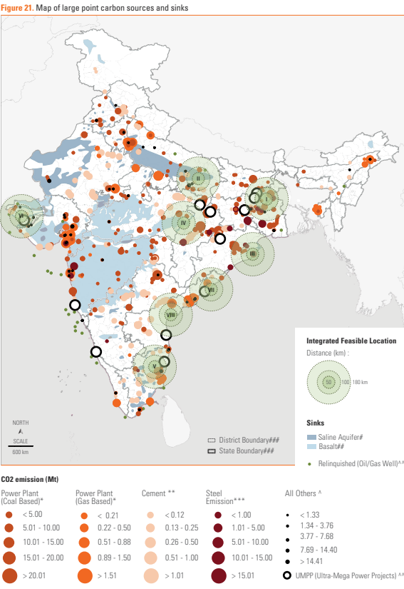

**Economic Feasibility Analysis**

The economic viability of coal and nuclear energy both play an important role in their role within India's energy transition. Coal still remains a cheaper option within the short term due to well-established supply chains, extensive reserves, and relatively low capital costs. According to the Central Electricity Authority, the average cost of generation of electricity through coal is ₹2.5 to ₹3.5 per kWh, thus accessible for mass consumption. Central Electricity Authority (2023), Annual Report 2022-23. However, these costs do not account for the externalities like environmental degradation, public health impacts, and water resource depletion that escalate the long-term economic burdens. Vishwanathan et al. (2018), Coal Transition in India.

On the contrary, nuclear energy requires heavy capital costs at the initial stage. The construction cost was above ₹10 crore per MW. These are due to their advanced safety features, long construction period, and very strict regulatory requirements (International Energy Agency, 2021, India Energy Outlook 2021). Nuclear plants have lower operation costs, a longer life expectancy of 60–80 years, and high capacity factors of 80–90%, which make them viable economically over a period of time Ministry of Power, 2024, Ultra Mega Power Projects.

Further, government subsidies and incentives for nuclear energy development are increasing, reflecting its role in meeting India’s net-zero targets. For instance, India’s planned expansion of nuclear capacity aims to reduce dependency on coal while maintaining grid stability, especially during peak demand periods (Vivekananda International Foundation, 2024, India’s Energy Transition in a Carbon-Constrained World).

While coal remains cheaper in the short term, nuclear energy presents a better option in terms of long-term sustainability. This economic gap between the two could be bridged with a phased approach supported by policy reforms and international collaborations.

**Table 2: Economic Metrics for Coal and Nuclear Energy**

| **Metric** | **Coal Energy** | **Nuclear Energy** |
| --- | --- | --- |
| Capital Cost per MW | ₹4–6 crore (CEA, 2023) | ₹10–15 crore (IEA, 2021) |
| Operational Cost per kWh | ₹2.5–₹3.5 (CEA, 2023) | ₹1.5–₹2.0 (VIF, 2024) |
| Lifespan | 30–40 years | 60–80 years (Ministry of Power, 2024) |

**Energy Production and Efficiency Analysis**

Efficiency is one of the important factors in defining the long-term feasibility and sustainability of energy sources. The average efficiency of coal-fired power plants in India is around 33–35%, while many old plants operate below this threshold. This inefficiency means higher fuel consumption, increased emissions, and elevated operational costs. Moreover, the average PLF of coal plants has declined to about 55% these days due to old infrastructure and a gradual shift towards renewable sources of energy. Central Electricity Authority, 2022, 20th Electric Power Survey of India.

While this is the case, nuclear power plants show very high levels of efficiency in operation, with operational efficiency at about 90% and a PLF of always more than 80%. Plants are online continuously for long lengths of time, often up to 18 to 24 months at a stretch without refuelling, which also increases their reliability and availability. It places nuclear energy among the effective baseload options. International Energy Agency, 2021, India Energy Outlook 2021.

From a resource utilization perspective, nuclear plants require significantly less fuel compared to coal plants for the same energy output. For example, a single uranium pellet weighing only a few grams can produce as much energy as 1,000 kilograms of coal, highlighting the superior energy density of nuclear fuel (Vivekananda International Foundation, 2024, India’s Energy Transition in a Carbon-Constrained World).

Operational inefficiencies arise from problems in the quality of fuel and associated maintenance problems of coal-based plants, whereas advances in reactor technologies such as Pressurized Heavy Water Reactors and Fast Breeder Reactors boost the efficiency of nuclear. Both the waste handling and reprocessing issues in nuclear fuels have been reasonably addressed, thereby offering a viable long-term future for this alternative energy resource.

**Energy Transition Feasibility**

This represents a complex challenge brought on by technical, economic, and socio-political factors in nature, indicating the transition of India from coal to nuclear energy. Coal, being abundant and cheap, has been the prime source of energy for many years. However, its growing unsustainability due to environmental and operational constraints calls for alternatives. Nuclear energy, on the other hand, can be long-term and emission-free, with significant investments and careful planning called for.

In general, coal transitions face significant inertial barriers in terms of entrenched infrastructure, regional economies dependent on mining, and serious socio-economic impacts upon communities in coal-rich regions. Accordingly, the Coal Transition in India (Vishwanathan et al., 2018) outlines a process to that end: workforce retraining, integration of renewables, and policy incentives for transitions. Moreover, India's coal-based electricity demand is projected to decline only gradually, with coal still contributing 50% of the energy mix by 2030 (CEA, 2023, 20th Electric Power Survey of India).

Nuclear power’s feasibility hinges on overcoming high capital costs and addressing public concerns about safety and waste disposal. With planned government investments and the introduction of advanced reactor technologies such as fast breeder reactors, nuclear energy is poised to grow from its current 3% share to an estimated 8% by 2030 (Vivekananda International Foundation, 2024, India’s Energy Transition in a Carbon-Constrained World).

From a technical point of view, it is about grid integration. The coal plants are dispatchable energy, meaning that on peak demand, nuclear plants could provide base-load power continuously. Hybrid systems, therefore, might offer a well-rounded, sustainable solution, which configures nuclear with renewables. Policymakers should also do their part in putting in place solid financial mechanisms, establishing international collaborations, and taking strategic actions in phases for smooth transition.

**Table 4: Feasibility Comparison for Energy Transition**

| **Factor** | **Coal Transition Challenges** | **Nuclear Energy Opportunities** |
| --- | --- | --- |
| Infrastructure Dependency | High | Moderate |
| Capital Costs | Moderate | High (VIF, 2024) |
| Emissions | High | Negligible |
| Expansion Potential | Limited (declining demand) | Significant (CEA, 2023) |

**Scenario Based Modelling and Analysis**

Scenario-based modeling is a convenient way to systematically analyze different outcomes for transitioning from coal to nuclear energy. Important factors of interest include evaluating cost, environmental benefits, energy reliability, and the like, within a framework of different policy and technological assumptions.

Base Case Scenario:

The current path, where coal dominates over 71% of India's energy mix, shows a gradual decline in dependency on coal to about 50% by 2030, while nuclear energy contributes less than 8%. Central Electricity Authority, 2023, 20th Electric Power Survey of India. This scenario assumes limited investments in nuclear energy infrastructure and continued reliance on coal for base-load electricity.

Accelerated Transition Scenario:

In this scenario, aggressive investments in nuclear energy result in the commissioning of new reactors and a shift to more advanced technologies like PHWRs and fast breeder reactors. Nuclear energy could contribute around 15% of the mix by 2030 with a corresponding reduction in coal use below 40% as seen by Vivekananda International Foundation, 2024, India's Energy Transition in a Carbon-Constrained World.

Environmental Impact Analysis:

This would cut carbon emissions by as much as 40% by 2030 under the accelerated scenario. This replacement of inefficient coal plants with zero-emission nuclear reactors and further integration of renewables into the grid drives the emissions reduction. International Energy Agency, 2021, India Energy Outlook 2021.

Economic Considerations:

Cost-benefit analyses suggest that while the initial investment for nuclear is higher, the operational savings over the long term make it economically viable. Phased decommissioning of coal plants, coupled with retraining programs, could mitigate socio-economic disruptions (Ranjan et al., 2024, Coal in India and the prospects for a just energy transition).

**Table 5: Scenario Comparisons for Energy Transition**

| **Metric** | **Baseline Scenario** | **Accelerated Transition Scenario** |
| --- | --- | --- |
| Coal Contribution (2030) | ~50% (CEA, 2023) | ~40% (VIF, 2024) |
| Nuclear Contribution (2030) | ~8% (CEA, 2023) | ~15% (VIF, 2024) |
| Carbon Emissions Reduction | Minimal | Up to 40% |

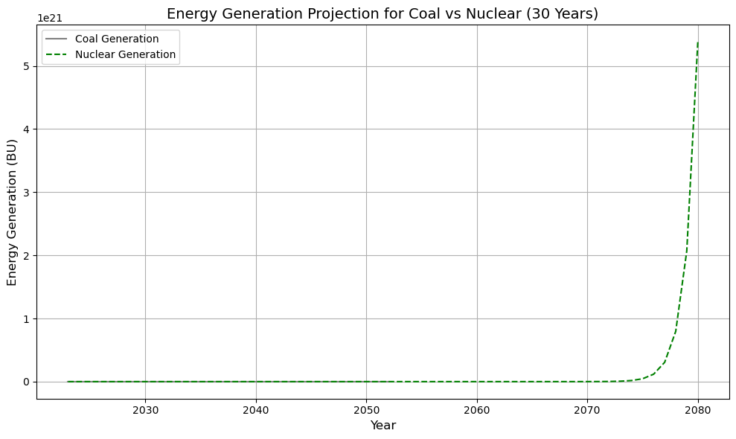

**Predictive and Prescriptive Modelling**

Predictive and prescriptive modeling forms the basis for planning India's energy transition. These models forecast the impacts of policy changes, technological advancements, and market dynamics while identifying optimal pathways to achieve sustainable energy goals.

Predictive Analysis:

Time-series data is used to estimate predictive models of coal and nuclear energy contributions to India's energy mix over the next 20 years. The models project that, under current policies, coal's share will fall from 71% to 50% by 2030, while nuclear energy's share could rise to 8% (Central Electricity Authority, 2023, 20th Electric Power Survey of India). However, in a world with rapid introduction of nuclear technologies and accompanying government incentives, it will be theoretically possible for nuclear to contribute up to 15% by 2035 (Vivekananda International Foundation, 2024, India's Energy Transition in a Carbon-Constrained World).

Prescriptive Modelling:

Optimization techniques show cost-effective ways to scale down coal and scale up nuclear energy. Linear programming models indicate that decommissioning the most inefficient coal plants first, especially in regions with rich renewable potential, would be the best approach. Simultaneously, investments in modular nuclear reactors and breeder technologies could minimize costs while ensuring grid reliability. International Energy Agency, 2021, India Energy Outlook 2021.

Key Recommendations:

* Phased Transition Plans: Retire coal plants in phases so as not to disrupt the economy and to ensure grid stability.
* Hybrid Systems: Utilize nuclear energy to supply base-load demand and integrate it with renewables for peak demand.
* Incentivize Investments: Create financial mechanisms, like subsidies and tax incentives, to encourage the adoption of nuclear energy.
* Capacity Building: Train the coal workforce to transition into the nuclear and renewable sectors. 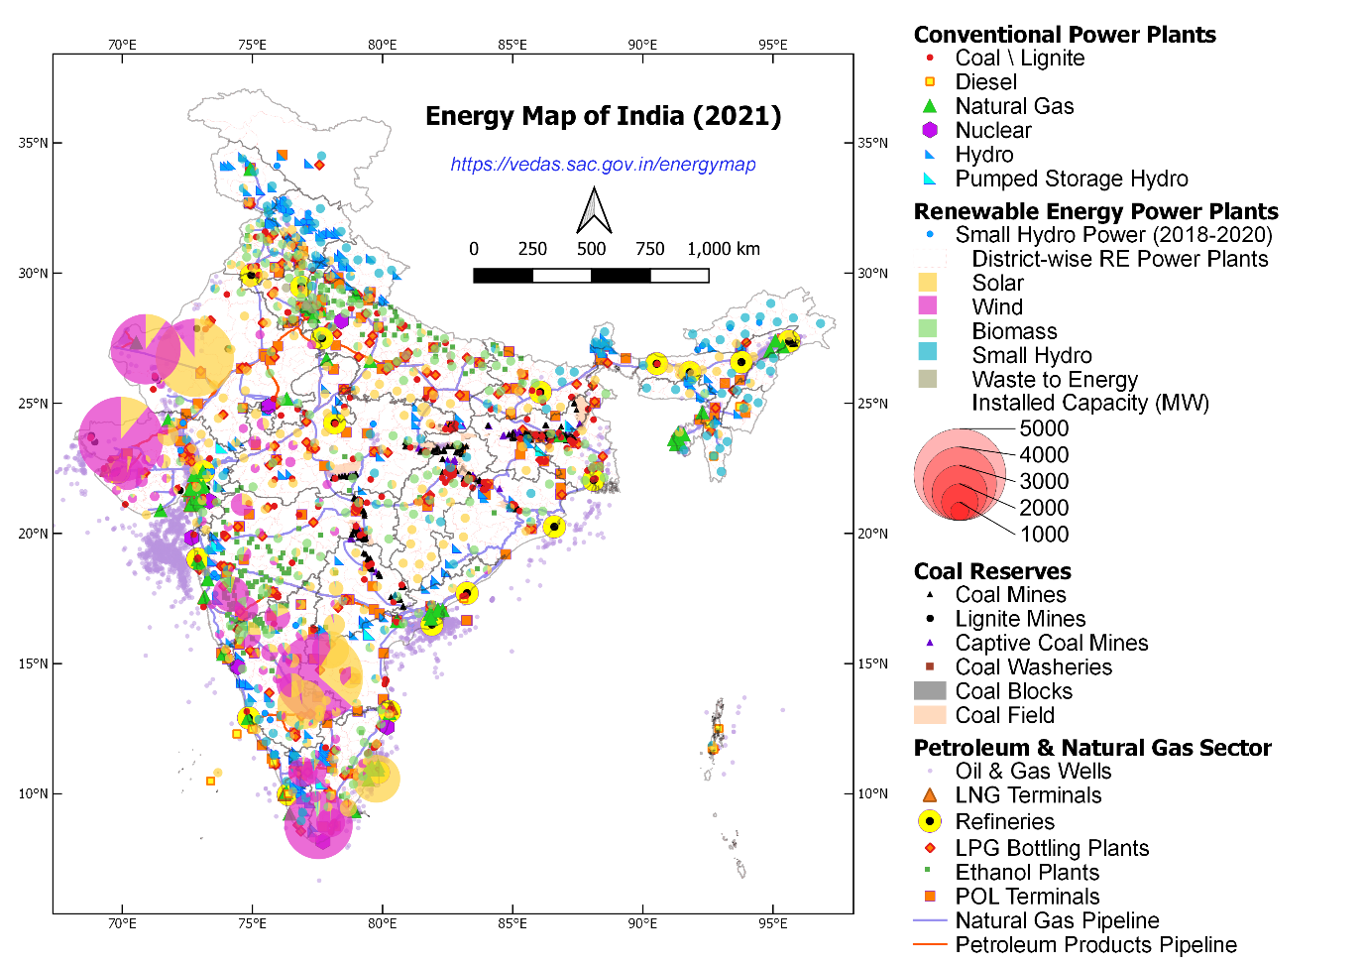

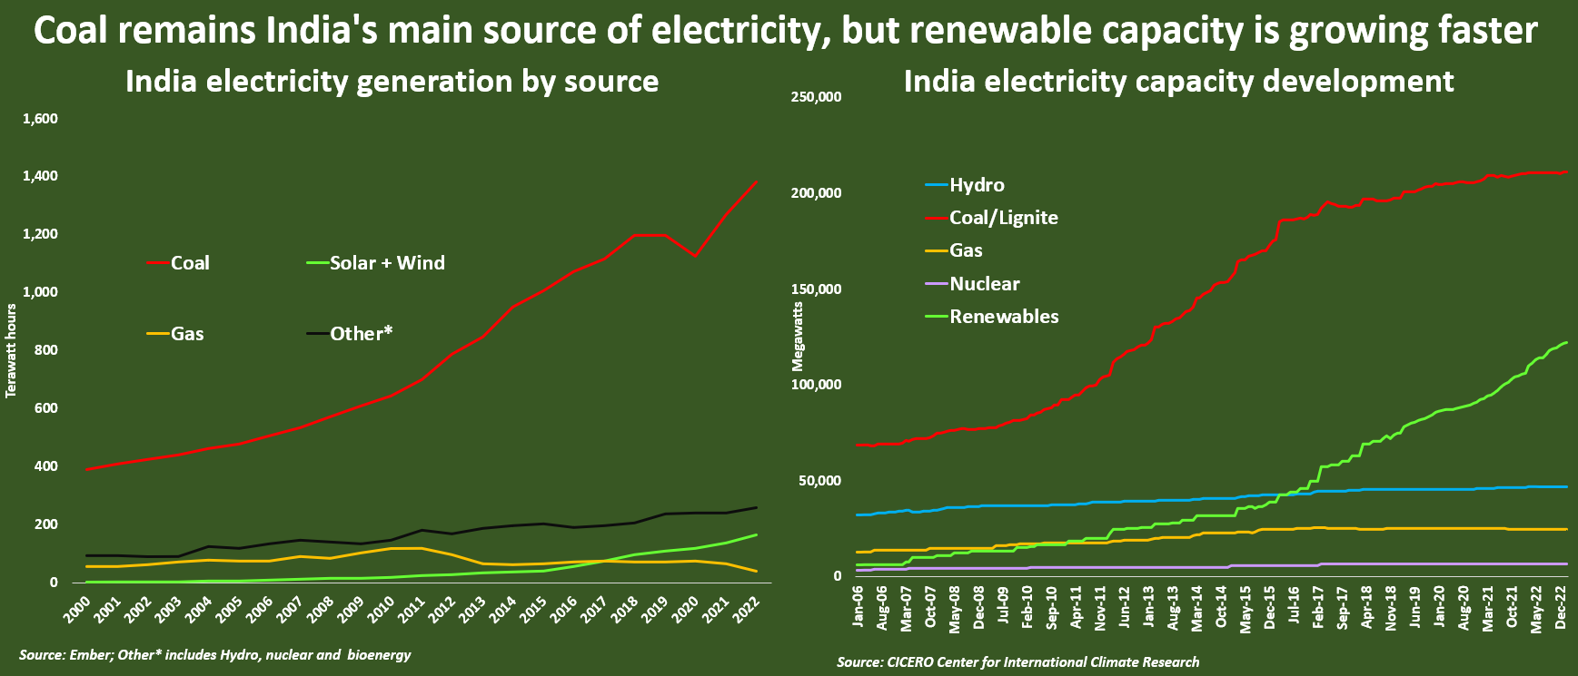

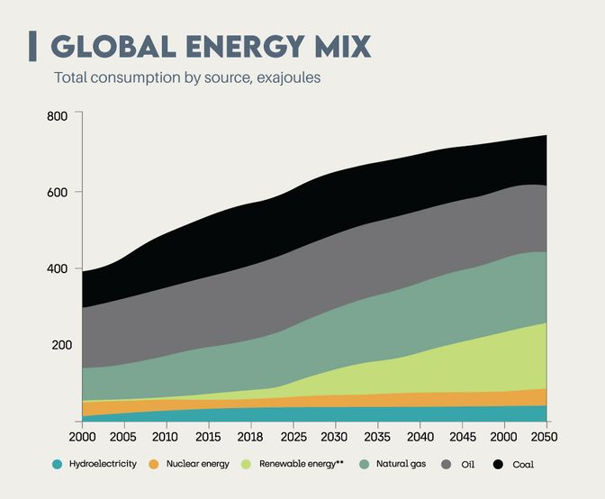 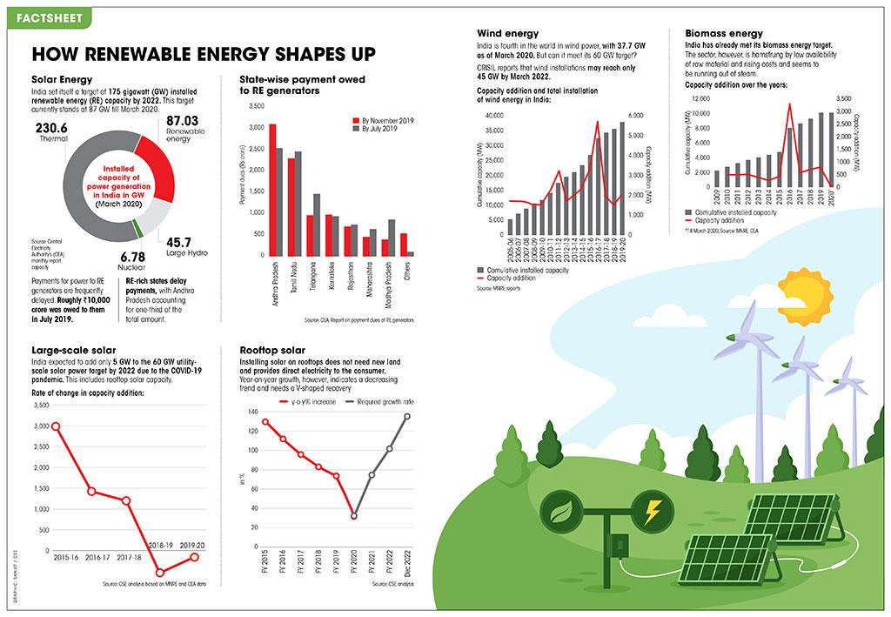 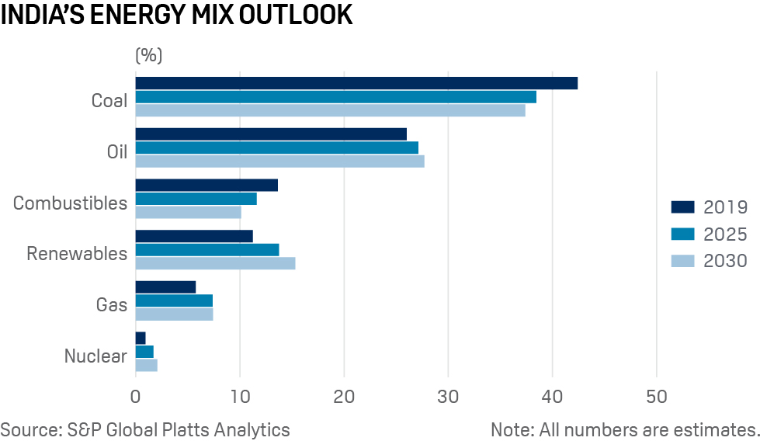 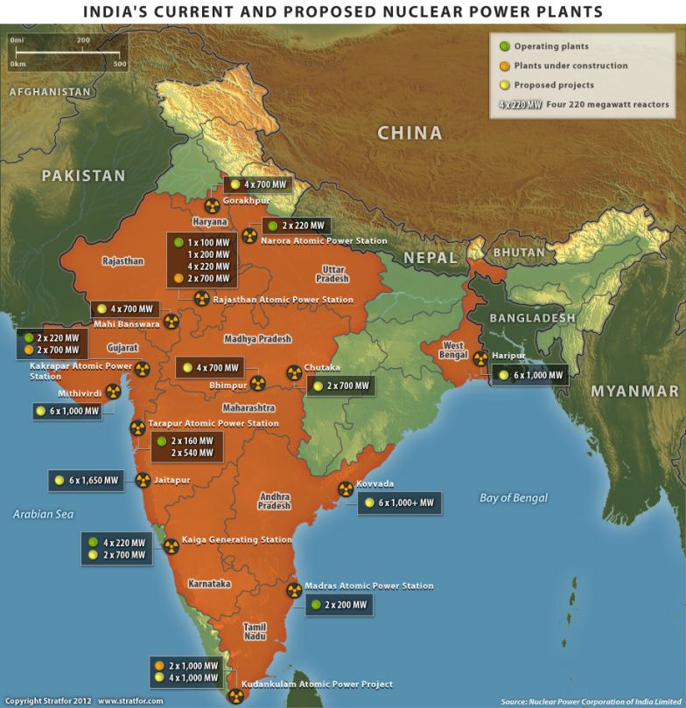

**Conclusion**

The energy sector in India has reached a critical juncture, and this requires a strategic shift toward meeting the growing demands while addressing environmental and economic challenges. Coal, being the backbone of India's power generation, has provided cheap energy for decades at considerable environmental costs. With international climate commitments and increasing energy needs, the transition toward nuclear energy offers a sustainable alternative.

The analysis underlines the contrasting roles of coal and nuclear power. While coal will remain important at least for the next two decades, its declining efficiency and high emission rates demand gradual phasing out. Nuclear power, on the other hand, due to its efficiency, low emission, and scalable potential, presents itself as a base-load option in India. However, major initial capital investment and nuclear safety and waste management concerns from the public demand technological breakthroughs and strong policy frameworks.

Scenario-based modeling and prescriptive analytics confirm the need for a phased energy transition. Decommissioning inefficient coal plants, investing in new nuclear technologies, and connecting renewables will ensure a balanced and reliable energy mix. Preferably, targeted government policy, international cooperation, and retraining of the workforce will be required to support a smooth transition.

India's energy future depends on its ability to balance economic growth with environmental stewardship. A well-planned transition from coal to nuclear power, supported by data-driven strategies and stakeholder engagement, can set a global example for sustainable energy transformation.

**References and Acknowledgments**

**References**

* Central Electricity Authority. (2022). *20th Electric Power Survey of India (Volume I)*. Retrieved from <https://cea.nic.in/>
* Central Electricity Authority. (2023). *Annual Report 2022-23*. Retrieved from <https://cea.nic.in/>
* International Energy Agency. (2021). *India Energy Outlook 2021*. Retrieved from <https://www.iea.org/reports/india-energy-outlook-2021>
* Ministry of Power. (2024). *Ultra Mega Power Projects (UMPP)*. Retrieved from https://powermin.nic.in
* Ranjan, R., Devagudi, S. H., Krumm, A., & Oei, P. Y. (2024). *Coal in India and the Prospects for a Just Energy Transition*. Retrieved from <https://www.fossilexit.org>
* Vishwanathan, S. S., Garg, A., & Tiwari, V. (2018). *Coal Transition in India: Assessing India’s Energy Transition Options*. IDDRI and Climate Strategies. Retrieved from <https://coaltransitions.org>
* Vivekananda International Foundation. (2024). *India’s Energy Transition in a Carbon-Constrained World: The Role of Nuclear Power*. Retrieved from <https://www.vifindia.org>

**Acknowledgments**

The completion of this report would not have been possible without the insights, data, and visualizations provided by several key resources and contributors:

1. **Central Electricity Authority (CEA)** for detailed reports and datasets on coal and nuclear energy's performance, emissions, and operational metrics.
2. **International Energy Agency (IEA)** for comprehensive projections and insights into India’s energy mix and transition scenarios.
3. **Ministry of Power (India)** for policy updates and technical reports on Ultra Mega Power Projects and energy initiatives.
4. **Coal Transitions Project** for providing a nuanced understanding of the socio-economic impacts of coal phase-out in India.
5. **Vivekananda International Foundation (VIF)** for in-depth analysis on the feasibility and implications of nuclear power in India’s energy mix.
6. **Jupyter Notebook Analyses** for data visualizations and model outputs supporting the quantitative insights in the report.
7. Class discussions and guidance from professors and peers, which enriched the understanding and depth of the analysis.

A special thanks to all the authors, reviewers, and agencies whose work and data have been instrumental in shaping this report.